Places of worship visited - to be completed by an official at each place. Churches should be open 10am - 5pm. If not open write 'not open' in the initials column.

Church | Time | Initials
Worcestershire and Dudley Historic
Churches Trust
Sponsored Ride and Stride

Saturday 8th September 2016
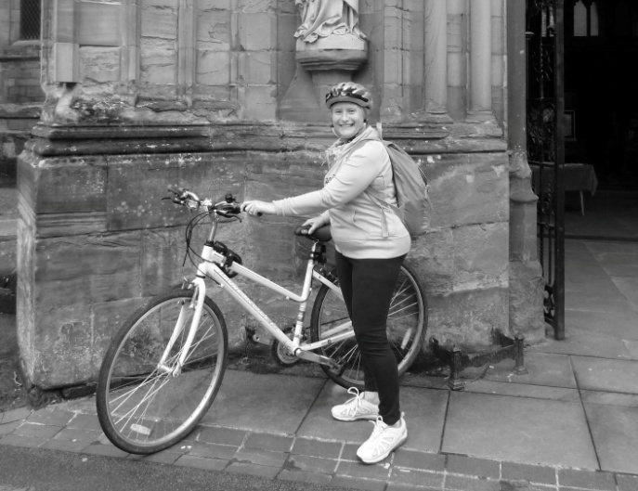

Half the money you raise will go to the church/chapel of your choice* and half will enable the Trust to continue to support churches with grants towards repairs, improvements and maintenance costs.

Donations are welcome if you prefer not to get sponsors
www.worcesteranddudleyhistoricchurches.org.uk

*Please note that you must raise more than £30 in order for half to be returned to your chosen church/chapel. Smaller sums will go to continue the work of the Trust

Places of worship visited - to be completed by an official at each place. Churches should be open 10am - 5pm. If not open write 'not open' in the initials column.
Church | Time | Initials

Church | Time | Initials

